**Structure of Your Project Report / Notebook**

**🧩 1. Title & Introduction**

* **Project**: SMS Spam Detection using NLP & Machine Learning
* **Goal**: Build a model to classify messages as spam or ham, and understand key indicators using explainable AI techniques.

**📊 2. Exploratory Data Analysis (EDA)**

* Count of spam vs ham
* Message length distributions
* Word cloud for spam vs ham

✅ **Code:**

python

CopyEdit

df['label'].value_counts().plot(kind='bar', title='Spam vs Ham Count')

# Length distribution

df['message_length'] = df['message'].apply(len)

df['message_length'].hist(by=df['label'], bins=50, figsize=(12,4), color='skyblue')

**🧼 3. Text Preprocessing + TF-IDF**

python

CopyEdit

from sklearn.feature_extraction.text import TfidfVectorizer

vectorizer = TfidfVectorizer(stop_words='english', max_df=0.95)

X = df['message']

y = df['label_num']

# Train-test split + reset index

from sklearn.model_selection import train_test_split

X_train, X_test, y_train, y_test = train_test_split(X, y, test_size=0.2, random_state=42)

X_train = X_train.reset_index(drop=True)

X_test = X_test.reset_index(drop=True)

y_train = y_train.reset_index(drop=True)

y_test = y_test.reset_index(drop=True)

X_train_tfidf = vectorizer.fit_transform(X_train)

X_test_tfidf = vectorizer.transform(X_test)

**🧠 4. Model Building & Evaluation**

Train both models and compare:

python

CopyEdit

from sklearn.linear_model import LogisticRegression

from sklearn.naive_bayes import MultinomialNB

from sklearn.metrics import accuracy_score, confusion_matrix, classification_report

lr_model = LogisticRegression()

nb_model = MultinomialNB()

lr_model.fit(X_train_tfidf, y_train)

nb_model.fit(X_train_tfidf, y_train)

# Predict

y_pred_lr = lr_model.predict(X_test_tfidf)

y_pred_nb = nb_model.predict(X_test_tfidf)

# Evaluation

print("Logistic Regression:\n", classification_report(y_test, y_pred_lr))

print("Naive Bayes:\n", classification_report(y_test, y_pred_nb))

🎯 **Select best model** based on F1-score (usually logistic regression does better here).

**📌 5. Insights**

**🔹 Logistic Regression Coefficients**

python

CopyEdit

feature_names = vectorizer.get_feature_names_out()

coefficients = lr_model.coef_[0]

# Top spam/ham words

top_spam = sorted(zip(feature_names, coefficients), key=lambda x: x[1], reverse=True)[:20]

top_ham = sorted(zip(feature_names, coefficients), key=lambda x: x[1])[:20]

**🔹 Word Clouds**

python

CopyEdit

from wordcloud import WordCloud

import matplotlib.pyplot as plt

spam_words = ' '.join(df[df['label_num'] == 1]['message'])

WordCloud(width=800, height=400).generate(spam_words).to_image()

**🔹 Optional: SHAP (for advanced visual explainability)**

**🧳 6. Packaging for Submission**

* Export model:

python

CopyEdit

import joblib

joblib.dump(lr_model, "spam_model.pkl")

joblib.dump(vectorizer, "tfidf_vectorizer.pkl")

* Save notebook as PDF or HTML
* Add README with:
  + 📌 Problem Statement
  + 💡 Summary of Results
  + 📈 Accuracy / F1 Score
  + 🧠 Key Insights

Initial data anyalyis

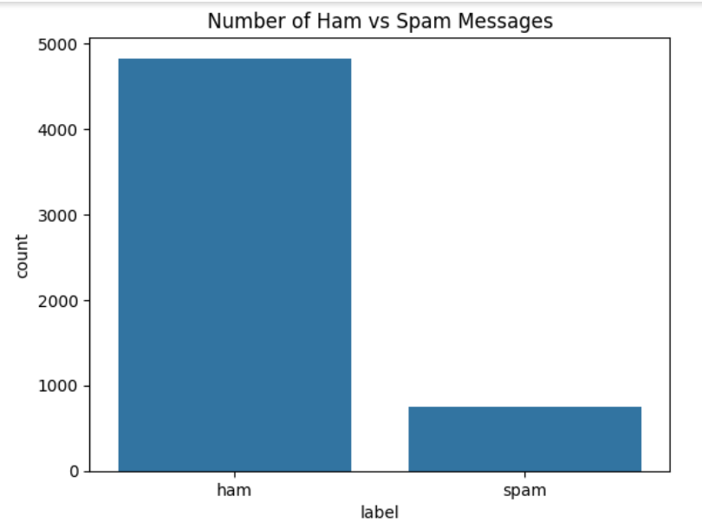

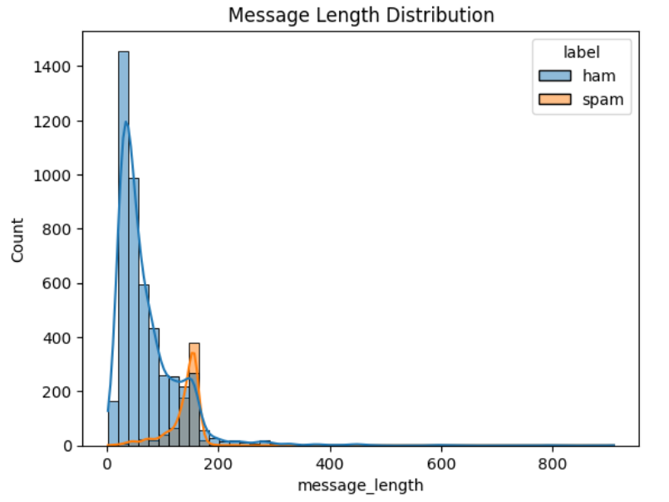

Model selection

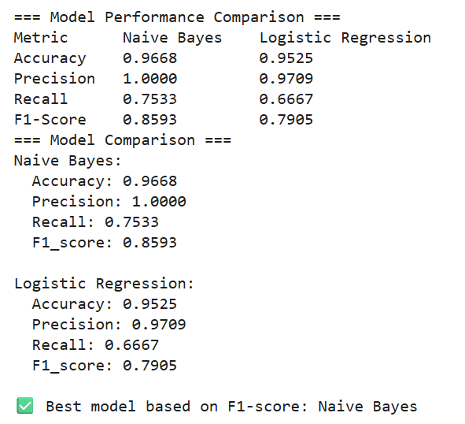

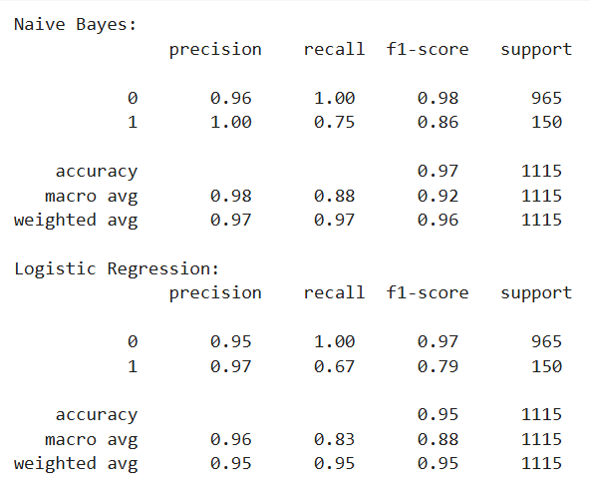

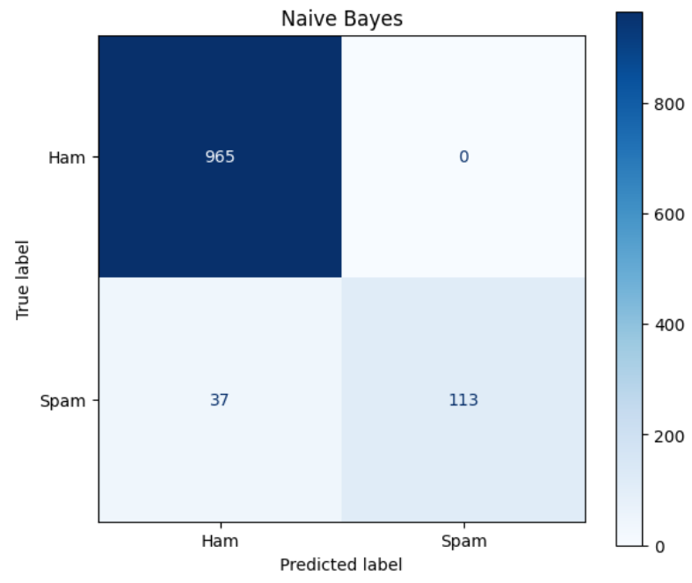

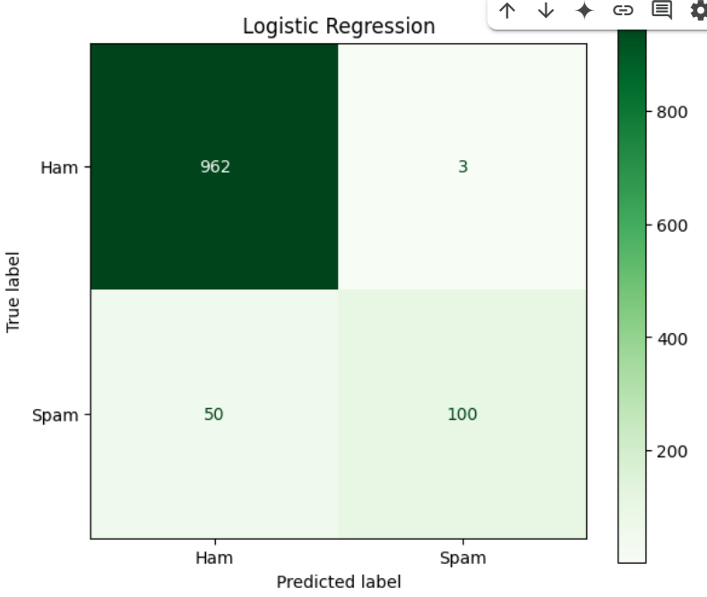

**Insights**

